Minutes

Morganton Planning & Zoning
May 11, 2023

Members Present: Members Absent:
Hank Dickens, Chairman Judy Francis
Pete Wallace, Vice Chairman Don Smith
Eric Engstrom Bill Lennon
Waits Gordon
Rick Lingerfelt
Erin Kizer

Also present from the City staff were Wendy Smith, Director Development & Design; Louis Vinay, City Attorney; Jackie Cain, Administrative manager

- OLD BUSINESS:

Item 1: Review and approval of minutes.

Mr. Dickens stated a minutes from the April 13, 2023 were provided for review. Minutes were approved as submitted. (6-0)

Item 2: Review of City Council action since last meeting

Mr. Dickens stated Ms. Smith would review action taken by city council. Ms. Smith stated city council met May 1, 2023 and reviewed the requests for approval.
- amendments to dimensional standards as presented in proposed updated Table 4.3 Performance Residential Density and Dimensional Standards of Section 4.2.3 Maximum Residential Performance Density and Dimensional Standards to support townhome-style development within the City of Morganton and proposed changes to performance standard options. This action is consistent with the approved land use plan as that development type is permitted under the approved land use plan.
- amendments to Table 4.5 Performance Points Density Bonus Scale and Table 4.6 Performance Standard Options of Section 4.3.1 Performance Standards for Residential Development to clarify current options, and provide additional options, for performance standard points to support development within the City of Morganton. This action is consistent with the approved land use plan as various densities of development are supported within the land use plan.
- amendments to the Zoning Ordinance to align with NCGS Chapter 160D. This action is consistent with the approved land use plan as it is simply aligning the City of Morganton Zoning Ordinance with NCGS Chapter 160D terminology and requirements.
- amendments for minor edits to modify or clarify requirements and address typographical errors. This action is consistent with the approved land use plan as it provides clarity on requirements and corrects errors in the current Zoning Ordinance.
- permission for Director of Development and Design Services Department to make other minor clerical changes to the Zoning Ordinance as required. This action is consistent with the approved land use plan as it provides opportunity to correct errors in the current Zoning Ordinance.
City Council approved the amendments.

II. APPEARANCES:

Mr. Dickens stated this time is set-aside for individuals to come before the planning board to express any planning related concerns to the planning board.

None.

- NEW BUSINESS:

Item 1: Consideration for an application submitted by Airlie, Inc to rezone the property listed as 0 Sanford Drive (PIN # 2704143120). The property is currently zoned Medium Intensity District with a River District Overlay (MID-RDO) and the application is to re-zone to High Intensity District with River District Overlay (HID-RDO).

Mr. Dickens asked for Ms. Smith to review this item.

Ms. Smith stated 0 Sanford Drive Pin#- 2704143120 owner requested for map amendment request and provided summary of the location.

Background
An application has been submitted by Ginny Erwin for Airlie Inc. to rezone the 8.04 acre property listed as 0 Sanford Drive, Pin#- 2704143120. The property is located at northwest corner of Lenoir Road and Sanford Drive, as shown on Map 1– Location Map. The property is currently zoned Medium Intensity District (MID) with the River District Overlay and is vacant and undeveloped.

Access – The property is located on the corner of Sanford Drive and Lenoir Road (Highway 18 North), with street frontage to both roads. It is likely that at a future date, when development of the site occurs, access will be required to be taken from Sanford Drive.

Water – The property has access to the public water system. If upgrades are required to service future developments, the upgrades will be at developer expense.

Sewer – The property has access to the public sewer system. If upgrades are required to service future developments, the upgrades will be at developer expense.
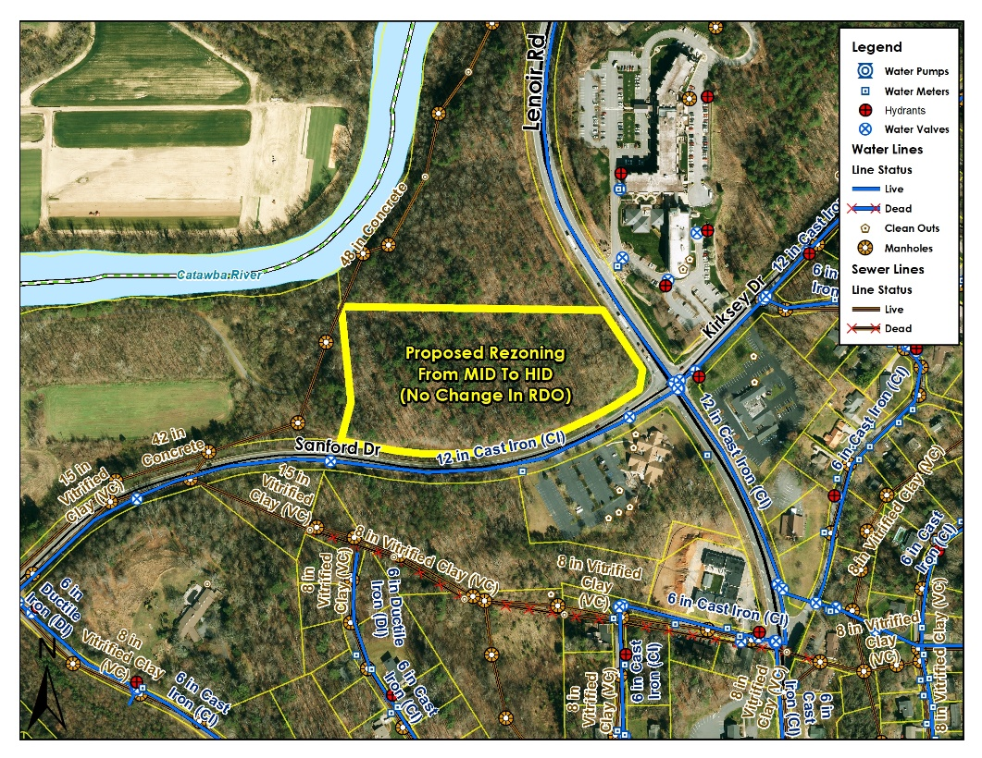
Surrounding Development – To the north and west, the site directly adjoins land also in Zone MID, owned by the City of Morganton and developed with recreational uses. Across Lenoir Road is the Grace Ridge development, located in Zone MID, developed with a mix of single-story, two-family units, and four to six story multi-family residential structures, as well as nursing facility. Across Sanford Drive to the south, is North Morganton United Methodist Church, in Zone MID. Diagonally across from the subject site is Kirksey Funeral Home, in Zone MID.

Proposal
The application is to re-zone the lot to High Intensity District (HID) with the River District Overlay. The applicant has stated that the purpose behind the rezoning request is to allow the site to be developed for multi-story, multi-family residential apartments; see Attachment 1 for the applicant’s proposal, noting that a rezoning would allow any permitted use in HID to be developed on the site, not only multi-family residential.

Zone Comparison
The Medium Intensity District is intended for a variety of medium to high density residential and low to medium intensity civic, institutional, office, service, and retail uses designed to keep the impact on adjacent residential areas at a minimum.

The High Intensity District is established to accommodate high density residential and a wide variety of civic, institutional, retail, service, and office uses along major arterials within the City and to ensure these uses are attractive, functional, and do not have a harmful effect on adjacent neighborhoods or other commercial areas of the City.
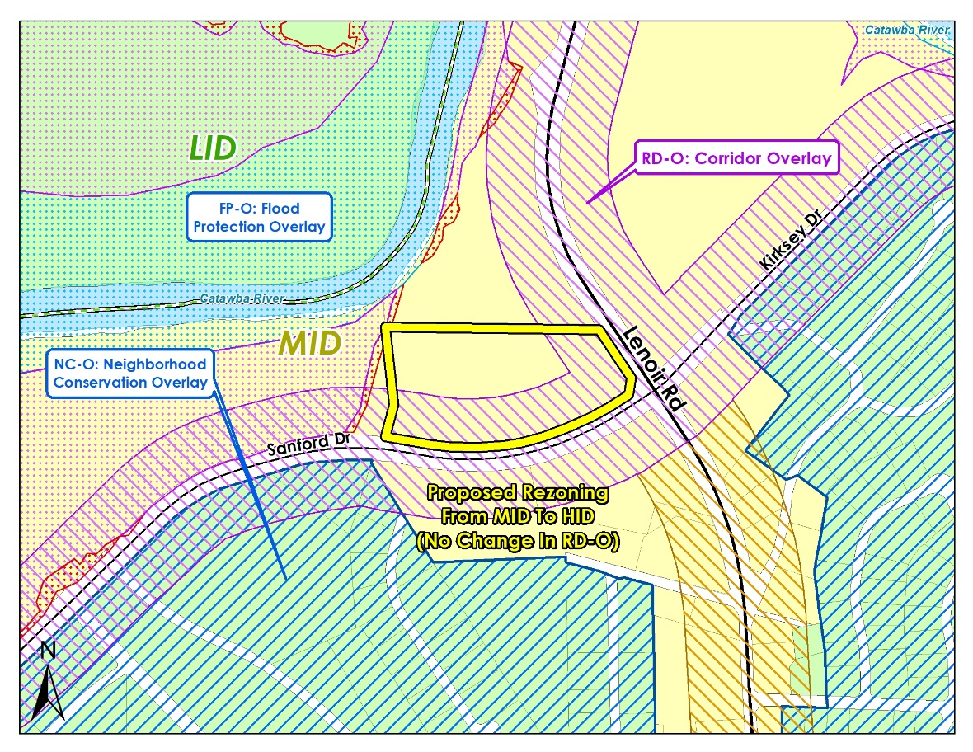

The intent of the River District Overlay is to protect and conserve the natural setting of area in the vicinity of the Catawba River and Catawba Meadows Park and to promote compatible recreation and tourist-based development. This overlay applies to any portion of the property within 250 feet of Lenoir Road and Sanford Drive.
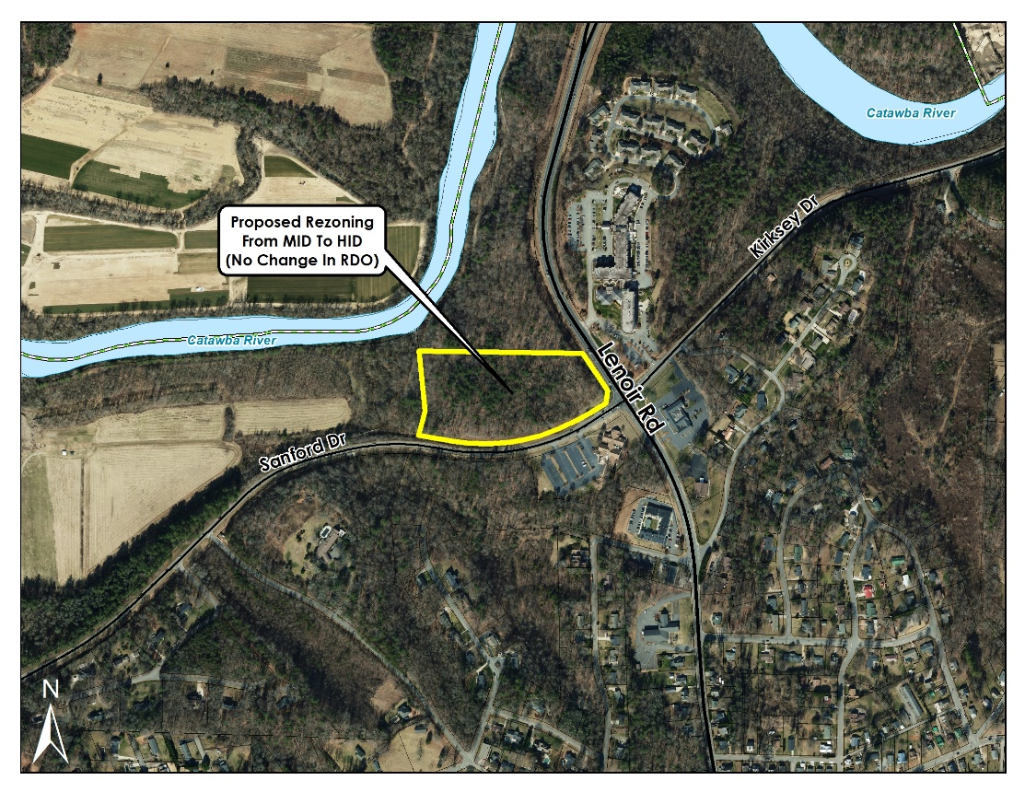
The following table shows a comparison of permitted uses in the two zones, along with Overlay exceptions:

Agricultural Uses | Overlay Exceptions | MID | HID
Bona fide farms (excluding swine production, see Section 1.4.2 for ETJ exemption) | Not permitted in NC-O, RR-O | P | P
Equestrian uses (horseback riding, stables) |  | P | P
Livestock and fowl keeping (accessory to residential use) |  | P | P
Livestock and fowl keeping (principal use) | Not permitted in NC-O, RR-O
Greenhouse or horticultural nursery (no retail sales) | Not permitted in NC-O, RR-O |  | P
Produce Stand (permanent) | Not permitted in NC-O, RR-O | P | P
Residential Uses | Overlay Exceptions | MID | HID
Accessory dwellings |  | P | P
Accessory structures (residential) |  | P | P
Bed & breakfast inns |  | P | P
Boarding and rooming houses | Not permitted in NC-O | P | P
Family care homes |  | P | P
Home occupations, customary (includes daycare homes) |  | P | P
Home occupations, intensive | Not permitted in NC-O | P | P
Manufactured homes on individual lots-see Section 3.2.2 | Only permitted in MH-O
Multi-family dwellings (includes apartments & townhomes) | Not permitted in NC-O | P | P
Single-family dwellings (detached) |  | P | P
Two-family dwellings (duplexes) | Not permitted in NC-O | P | P
Civic, Government, & Institutional Uses | Overlay Exceptions | MID | HID
Cemeteries | Not permitted in NC-O, RR-O | P | P
Colleges, universities, & associated facilities |  |  | P
Community outreach offices | Not permitted in NC-O | P | P
Correctional facilities | Not permitted in C-O, RD-O |  | P
Daycare centers, child and adult | Not permitted in NC-O | P | P
Emergency services (fire, police, EMT, & similar uses) | Not permitted in NC-O | P | P
Government office buildings | Not permitted in NC-O | P | P
Hospitals, public and private |  |  | P
Libraries, museums, art galleries, & similar uses | Not permitted in NC-O, RR-O | P | P
Post offices | Not permitted in NC-O, RR-O | P | P
Religious institutions & related uses | Not permitted in NC-O, RR-O | P | P
Research facilities | Not permitted in RR-O |  | P
Residential care facilities | Not permitted in NC-O | P | P
Residential shelters | Not permitted in NC-O | P | P
Schools, instructional (music, dance, martial arts, etc.) | Not permitted in NC-O | P | P
Schools & associated facilities (public & private) | Not permitted in NC-O | P | P
Schools (trade & vocational) | Not permitted in NC-O | P | P
Social, fraternal, & philanthropic clubs & lodges, & similar uses operated on a non-profit basis | Not permitted in NC-O | P | P
Office & Service Uses | Overlay Exceptions | MID | HID
Animal services (no outdoor kennels) | Not permitted in NC-O | P | P
Animal services (with outdoor kennels) | Not permitted in NC-O | P | P
Artists, craftsmen | Not permitted in NC-O | P | P
Banks, financial services | Not permitted in NC-O, RR-O | P | P
Body art establishment (tattoos & body piercing) | Not permitted in C-O, RD-O, RR-O |  | P
Crematories |  |  | P
Dry cleaning and laundry services (non-industrial) | Not permitted in NC-O, RR-O | P | P
Funeral homes and mortuaries | Not permitted in NC-O, RR-O | P | P
Hotels and motels | Not permitted in RR-O |  | P
Motion picture production | Not permitted in RR-O |  | P
Motor vehicle and boat services (with or without outdoor storage, includes gas stations and car washes) | Not permitted in RR-O |  | P
Medical, dental, chiropractic, optical, psychiatric offices | Not permitted in NC-O, RR-O | P | P
Personal service uses | Not permitted in NC-O, RR-O | P | P
Professional offices | Not permitted in NC-O, RR-O | P | P
Services, other (no outdoor storage) | Not permitted in NC-O, RR-O | P | P
Services, other (with outdoor storage) | Not permitted in RR-O |  | P
Retail & Wholesale Uses | Overlay Exceptions | MID | HID
Auction Houses | Not permitted in RD-O, RR-O |  | P
Farmers’ markets | Not permitted in NC-O, RR-O | P | P
Microbreweries and wineries (with on-site sales) | Not permitted in NC-O, RR-O | P | P
Motor vehicle or boat sales or rental | Not permitted in RR-O |  | P
Mobile Food Vendors |  | P | P
Pawn shops | Not permitted in C-O, NC-O or RD-O, RR-O | P | P
Restaurants (no drive-through) | Not permitted in NC-O, RR-O | P | P
Restaurants (with drive-through) | Not permitted in NC-O, RR-O | P | P
Retail uses (less than 3,000 square feet, inside fully enclosed building) | Not permitted in NC-O, RR-O | P | P
Retail uses (3,000 square feet or greater, inside fully enclosed building) | Not permitted in RR-O |  | P
Retail uses (outside fully enclosed building) | Not permitted in RR-O |  | P
Wholesale (inside fully enclosed building | Not permitted in RR-O |  | P
Wholesale (outside fully enclosed building) | Not permitted in RR-O
Recreation & Entertainment Uses | Overlay Exceptions | MID | HID
Adult oriented businesses | Not permitted in C-O, RD-O, RR-O |  | P
Auditorium, assembly hall | Not permitted in NC-O | P | P
Banquet, events facility | Not permitted in NC-O | P | P
Campgrounds | Not permitted in NC-O, C-O, RR-O | P | P
Electronic gaming operations | Not permitted in C-O, NC-O, RD-O, RR-O |  | P
Golf, tennis, swimming clubs & related uses  (private, not in a development) | Not permitted in NC-O | P | P
Golf, tennis, swimming facilities, athletic fields & related uses (public) | Not permitted in NC-O | P | P
Motorsports competition and testing facilities | Not permitted in RR-O |  | P
Night clubs, bars | Not permitted in RR-O |  | P
Parks (public) |  | P | P
Private clubs | Not permitted in RR-O |  | P
Recreation facilities associated with a residential development |  | P | P
Recreation facilities (indoor, private) |  |  | P
Recreation facilities (indoor, public) | Not permitted in NC-O | P | P
Recreation facilities (outdoor, private-including golf driving ranges, miniature golf, skateboard parks, water slides, batting cages, go cart tracks, & similar uses) | Not permitted in C-O |  | P
Shooting ranges (indoor) | Not permitted in RR-O |  | P
Shooting ranges (outdoor-in association with local government only) | Not permitted in RR-O
Theater (drive-in) | Not permitted in RR-O |  | P
Theater (indoor) | Not permitted in NC-O, RR-O | P | P
Theater (open-air) | Not permitted in NC-O, RR-O | P | P
Banquet and Events-Accessory Use |  | P | P
Industrial, Transportation, & Utility Uses | Overlay Exceptions | MID | HID
Airports and heliports | Not permitted in C-O, RD-O, RR-O |  | P
Asphalt plants, mixing plants, concrete and asphalt | Not permitted in C-O, RD-O, RR-O
Automobile parking lots or garages (principal use) | Not permitted in NC-O | P | P
Bus and train stations | Not permitted in NC-O, RR-O | P | P
Data centers | Not permitted in RR-O |  | P
Distribution centers | Not permitted in RR-O
Electric transmission lines & appurtenances |  | P | P
Junkyards, salvage yards, recycling operations and similar uses | Not permitted in C-O, RD-O, RR-O
Landfill (construction, demolition, land clearing & inert debris) | Not permitted in RR-O
Landfill (sanitary) | Not permitted in RR-O
Manufacturing, processing, & assembly (inside fully enclosed building) | Not permitted in RR-O |  | P
Manufacturing, processing, & assembly (outside fully enclosed building) | Not permitted in C-O, RD-O, RR-O
Mining & quarrying operations | Not permitted in RR-O
Natural gas distribution lines & related appurtenances | Not permitted in RR-O | P | P
Power generation/production facilities (not including wind and solar) | Not permitted in C-O, RD-O, RR-O |  | P
Power generation/production, solar (individual use) | Not permitted in RR-O | P | P
Power generation/production, solar (solar farm) | Not permitted in C-O, RD-O
Power generation/production, wind (individual use) | Not permitted in C-O, RD-O
Power generation/production, wind (wind farm)
Rail terminals or yards | Not permitted in RR-O
Recycling centers (excluding recycling operations) |  |  | P
Sewage collection lines, pump stations, & appurtenances |  | P | P
Sewage treatment plants (non-government, public) | Not permitted in C-O, RR-O
Taxicab services | Not permitted in RR-O |  | P
Telecommunication lines & related appurtenances | Not permitted in RR-O | P | P
Telecommunications towers (may require Board of Adjustment approval-see Section 3.4.7 (H)) | Not permitted in NC-O,  C-O, or RD-O, RR-O | P | P
Transit stops |  | P | P
Truck stops | Not permitted in C-O, RD-O, RR-O |  | P
Warehouse uses (excluding mini-warehouses) | Not permitted in RR-O |  | P
Warehouse, mini | Not permitted in C-O, RD-O, RR-O |  | P
Water distribution lines, pumps, storage, tanks, & appurtenances |  | P | P
Water treatment plants (public) | Not permitted in RR-O
Other Uses | Overlay Exceptions | MID | HID
Accessory structures (associated with permitted non-residential uses) |  | P | P
Business kiosks (ATMs, movies, ice vending, etc.) | Not permitted in NC-O | P | P
Drive-through/drive-in uses (associated with permitted use) | Not permitted in NC-O | P | P
Outdoor storage (associated with a permitted use, excluding outdoor sales display) | Not permitted in C-O, RD-O |  | P
Temporary uses |  | P | P

Additionally, the following table provides a comparison of the dimensional and density standards (both base and performance standards) for each of the zones:

District | A1  Base  Max.  Residential  Density | A2  Residential  Min. Lot Size  (Square feet)¹ | B  Min. Lot Width  (feet) | C  Front  Setback  (feet) | D  Side  Setback  (feet) | E  Rear  Setback  (feet) | F  Max  Height (feet_
MID | 2 DUA | 20,000 | 70 | 20 | 10 | 20 | 35
HID | 6 DUA | 6,000 | 60 | 20 | 10 | 20 | 35

District | A  Performance Max. Residential Density¹ | B  Residential  Min. Lot Width  (feet)² | C  Front  Setback  (feet) | D  Side  Setback  (feet) | E  Rear  Setback  (feet) | F  Max.  Height (feet)
MID | 10 DUA | 50-detached  25-attached | 20 | 5-detached  0-attached | 15 | 50
HID | 20 DUA | 40-detached  25-attached | 20 | 5-detached  0-attached | 5 | 65

Rezoning the site to HID could allow any of the uses listed under HID in the table of uses above, not just the multi-family development the application is proposing, as well as the setback and height allowances under the base standards for HID. The consideration should be whether those base allowances are suitable for this site.

Comprehensive Plan Designation
The City’s Mission 2030 Comprehensive Plan’s Future Land Use Map, shown on Map 4 indicates that the subject parcel’s future land use would be best suited as Recreational/Open Space. Recreational/Open space land would typically be reserved for natural open space, parks and similar uses.
The City is currently undergoing an update to the Mission 2030 Comprehensive Plan and taking a fresh look at the Future Land Use Map. The suitability of land uses through the City will be considered as part of this process. It is preliminarily expected that re-evaluation of the subject area will support an increase in intensity of uses. 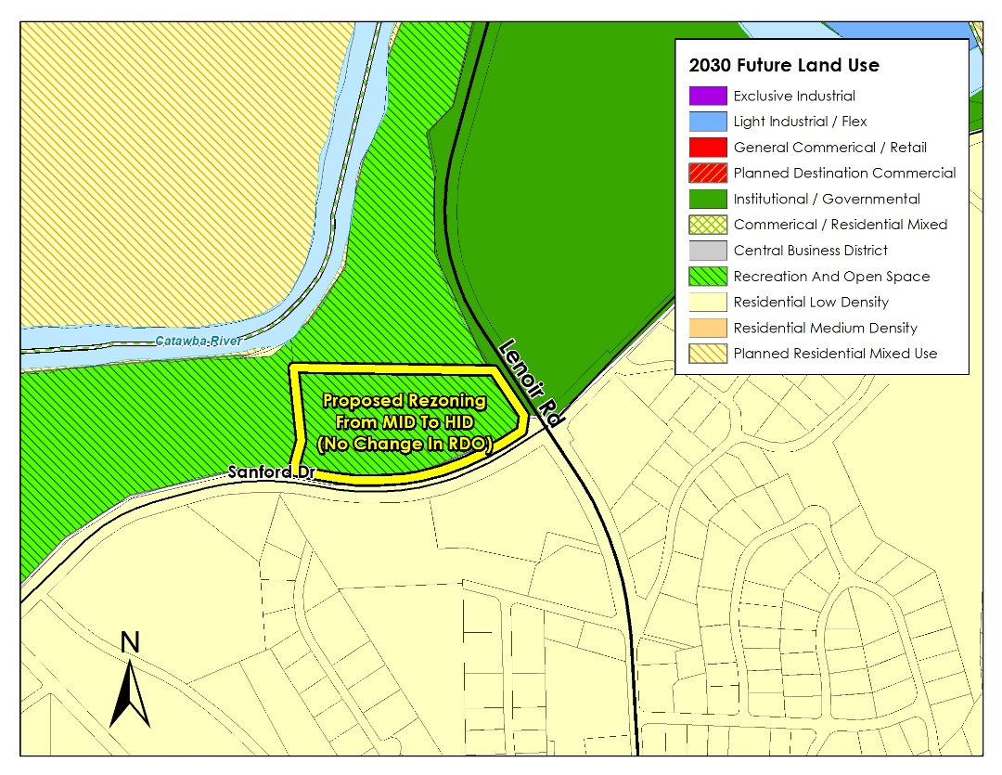

Assessment
While HID development is not in keeping with the 2030 Land Use Plan, the current MID zoning classification does allow other, less intense, non-recreational/open space uses to be developed at the site. Were the site to be developed with multi-family uses under either zone, it is difficult to say how many multi-family units could be developed, as the density and height would depend upon the number of performance points utilized by the developer at the time.

Rezoning this property from MID to HID could have potential impacts to surrounding roads with increased traffic; however, at time of site development, it is likely that NC Department of Transportation would require a Traffic Impact Assessment and implementation of any recommended roadway upgrades, at the developer’s cost, to address any concerns for the proposed development.
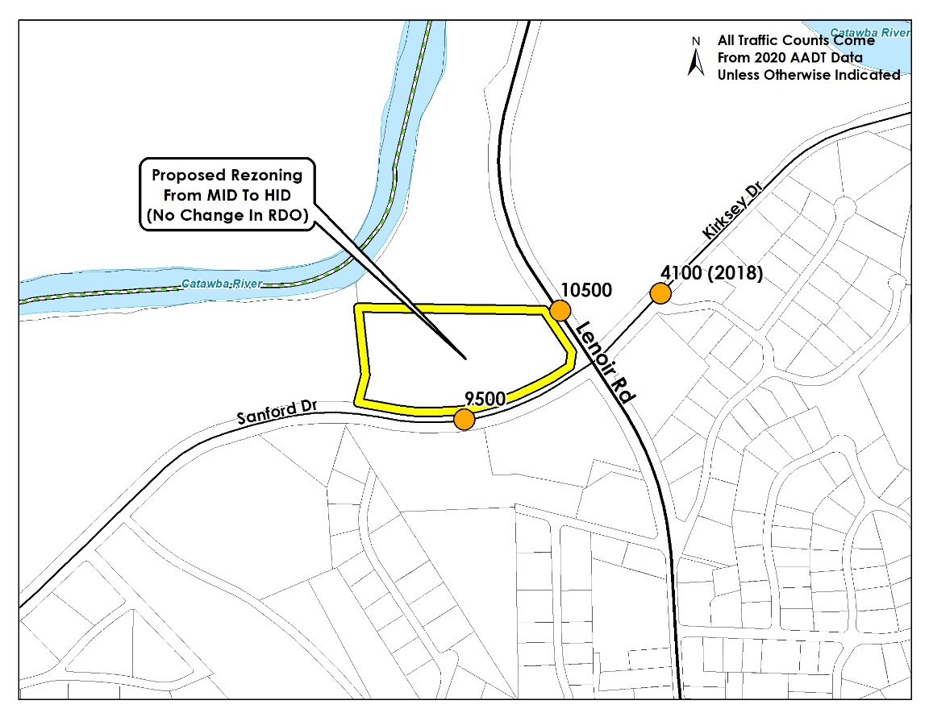

It is considered unlikely that a private owner would develop such a large site in this location for recreational purposes.

The proposal for HID development at 65 feet with higher densities, or for other non-residential/commercial uses, could be considered to be in keeping with the surrounding development of neighboring sites, particularly the multi-family residential and nursing facility use of Grace Ridge. The impact upon neighboring uses is expected to be less given the site’s immediate surroundings by high-traffic roadways and recreation uses. It is not expected that the development of the site in accordance with HID requirements would negatively affect the adjoining recreational land. There could be some additional increase in the use of the recreational land due to development of the subject site.

The inclusion of the River District Overlay with the current proposal is considered essential to any rezoning, and inclusion of the Overlay will serve to limit impacts upon neighboring properties that currently have the same Overlay use and design restrictions and continue a pleasant presentation to the streetscape for passersby.

Ms. Smith advised staff recommends that the Planning and Zoning Commission approve this rezoning to HID with River District Overlay, as:
- the subject site is unlikely to develop as recreational open space;
- traffic impacts from future development can be mitigated;
- the development of the site with multi-story, multi-family uses or other non-residential/commercial uses can be considered to be in keeping with surrounding development and the character of surrounding uses;
- the additional density available in HID, should the site be developed with housing, would fulfill a significant community need; and
- preserving the River District Overlay will provide some use and design restrictions to limit impacts upon neighboring properties and the streetscape.

Mr. Dickens asked commission if they had any questions for staff. He asked Ms. Smith what the maximum density that could be obtained for the location.

Ms. Smith stated 20 DUA x 8 = 160 units along with parking, recreational space and green space.

Ms. Smith added the maximum height is 65 feet. She said it could be a combination of retail and living space.

Ms. Kizer asked about the flood plain.

Ms. Smith stated it was of little concern as it is just the back tip.

Mr. Wallace asked Ms. Smith to review the River District restrictions.

Ms. Smith stated the intent of this overlay is to protect and conserve established neighborhoods with Low Intensity and Medium Intensity districts from more intensive or incompatible uses. Certain incompatible uses are excluded from Neighborhood Conservation Overlay. Properties within the Neighborhood Conservation Overlay shall follow the development standards as outlined throughout Article 4 for setbacks, building height, fences, roofs, exterior materials and garages.

Mr. Gordon asked if any access would be given from Hwy 18.

Ms. Smith stated it was highly unlikely. If there is it would be a right out and right in.

Mr. Dickens opened for public hearing.

None.

Mr. Dickens closed public hearing.

Mr. Wallace made a motion that the Planning and Zoning Commission recommend to the City Council support for the proposed rezoning of 0 Sanford Drive, Pin#- 2704143120, shown on the Mission 2030 Comprehensive Plan Future Land Use Map as Recreational/Open Space land from Zone Medium Intensity District with River District Overlay to Zone High Intensity District with River District Overlay, and the proposal is considered reasonable for the following reasons:
- the subject site is unlikely to develop as recreational open space;
- traffic impacts from future development can be mitigated;
- the development of the site with multi-story, multi-family uses or other non-residential/commercial uses can be considered to be in keeping with surrounding development and the character of surrounding uses;
- the additional density available in HID, should the site be developed with housing, would fulfill a significant community need; and
- preserving the River District Overlay will provide some use and design restrictions to limit impacts upon neighboring properties and the streetscape.
Seconded by Mr. Gordon and passed 5-0 (Mr. Engstrom abstains)

The proposed rezoning is inconsistent with the Future Land Use Map and support of the proposal will result in an amendment to the Future Land Use Map.

Mr. Dickens stated this item would be on the June 5, 2023 city council.

OTHER ITEMS OF DISCUSSION

Ms. Smith briefed commission on the comprehensive plan and how we would be proceeding. She encouraged commission to visit the web site frequently for post on the progression of the comprehensive plan. She stated on May 18, 2023 the advisory committee would meet.

ADJOURN

Next Scheduled P&Z Meeting: Thursday June 8, 2023 at 5:15 PM
City Hall Council Chamber

